Peer-Graded Assignment: Assignment – Part 1
Estimated time needed: 45 minutes
Great! You have now completed all four modules of this course. This week, you will complete the final assignment that will be graded by your peers. In this assignment, you will open a CSV file in Excel for the web, convert it to an Excel format, and then clean and prepare the data.

Software Used in this Assignment
The instruction videos in this course use the full Excel Desktop version as this has all the available product features, but for the hands-on labs we will be using the free ‘Excel for the web’ version as this is available to everyone.
Although you can use the Excel Desktop software if you have access to this version, it is recommended that you use Excel for the web for the hands-on labs as the lab instructions specifically refer to this version, and there are some small differences in the interface and available features.

Dataset Used in this Assignment
The dataset used in this lab comes from the following source: https://data.montgomerycountymd.gov/Government/Fleet-Equipment-Inventory/93vc-wpdr under a Public Domain license.
We are using a modified subset of that dataset for the lab, so to follow the lab instructions successfully please use the dataset provided with the lab, rather than the dataset from the original source.

Assignment Scenario
In this final assigment, you will be following the scenario of a recently hired Junior Data Analyst in a local government office, who has been tasked with importing some data from another department which relates to inventory information about their fleet of vehicles. The data is in comma-separated value (CSV) format and the data also needs cleaning up before you can start to run any kind of analysis on it.

Guidelines for the Submission
Download the file Montgomery_Fleet_Equipment_Inventory_FA_PART_1_START.CSV. Upload and open the file with Excel for the web and convert it to an .XLSX file. Then clean the data as detailed below.
Use the course videos from Module 3 and the lab ‘Hands-on Lab 5: Cleaning Data’ to help you complete these tasks.
Tasks to perform:
- Save the CSV file as an XLSX file: Change the ‘Viewing’ in the ToolTip to ‘Editing’inorder to save the file as an XLSX file. The file is converted when you click ‘Convert’ in the prompt.
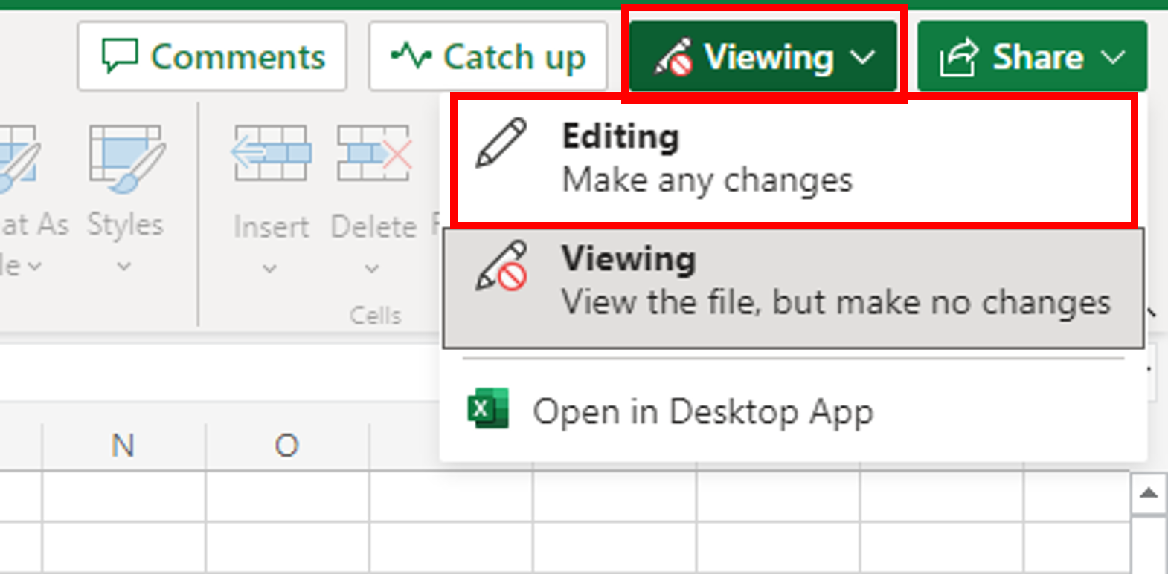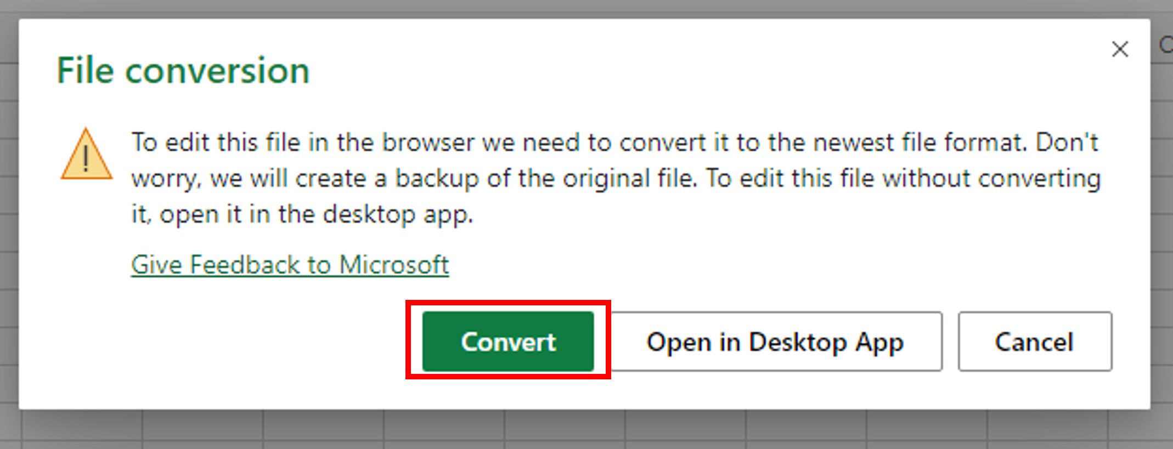
- Column widths: Sort out the widths of all columns so that the data is clearly visible in all cells.
- Empty rows: Use the Filter feature to look for blanks and remove all empty rows from the data.
- Duplicate records: Use either the Conditional Formatting or Remove Duplicates feature to look for and remove any duplicated records from the data.
- Spelling: The original source file data has not been checked for errors in the spelling. Check for spelling mistakes in the data and fix them.
- Whitespace: Use the Find and Replace feature to remove all double-spaces from the data.
- Department names: When the data was converted from its data source, the department names (see correct list below) didn’t import correctly and they are now split over two columns in the data. Use Flash Fill to reduce the department names to just one column, and then remove any unnecessary columns.
Department | Department
Board of Elections | Economic Development
Circuit Court | Environmental Protection
Community Engagement Cluster | Finance
Community Use of Public Facilities | Fire and Rescue
Consumer Protection | General Services
Correction and Rehabilitation | Health and Human Services
County Executives Office
- Download your workbook: Use‘Save As’and select‘Download a copy’ to download your completed workbook as Montgomery_Fleet_Equipment_Inventory_FA_PART_1_END.XLSX.
Note: In Excel web version, files are auto saved.

Grading Information
For your assignment to be graded in a subsequent step in this course, you will be required to upload the completed Excel workbook that you saved in Task 8.
The main grading criteria will be:
- Is the data saved correctly?
- Is the data formatted correctly?
- Has the data been cleaned correctly?
You will not be judged on:
- Your English language, including spelling or grammatical mistakes.
- The content of any text or image(s) or where a link is hyperlinked to.

Author(s)
- Steve Ryan

Other Contributor(s)
- Sandip Saha Joy

Changelog
Date | Version | Changed by | Change Description
2023-04-12 | 1.4 | Anita Verma | Updated step 1 and step 8
2021-10-11 | 1.3 | Malika | Updated dataset source link
2020-10-02 | 1.2 | Steve Ryan | Edited to use most recent version of Final Assignment instructions
2020-09-02 | 1.1 | Steve Ryan | Edited to use different datasets for Parts 1 and 2
2020-08-24 | 1.0 | Steve Ryan | Post ID review and published in course
2020-08-23 | 0.2 | Sandip Saha Joy | Converted to markdown in GitLab
2020-08-22 | 0.1 | Steve Ryan | Initial version created in Word

© IBM Corporation 2020. All rights reserved.

